PRESS RELEASE

COMMUNICATIONS AND MEDIA TEAM OF THE ASEAN SUMMIT 2023

No.60/SP/TKM-ASEAN2023/ENG/5/2023

Indonesian President Chairs Five Meetings on First Day of the 42nd ASEAN Summit 2023

West Manggarai, 10 May 2023 –On the first day of the 42nd ASEAN Summit 2023, Wednesday (10/5/2023), President Joko Widodo (Jokowi) will chair five meetings. The meetings will take place at Hotel Meruorah, Labuan Bajo, West Manggarai Regency, East Nusa Tenggara (NTT) Province.

“The Summit begins today with five meetings which will be chaired by the President,” said Ministry of Foreign Affairs Spokesperson Teuku Faizasyah on Wednesday (10/5/2023) in Labuan Bajo.

The meetings to be chaired by President Jokowi include the 42nd ASEAN Summit Opening and Plenary Session, ASEAN Leaders’ Interface Meeting with Representatives of the ASEAN Inter-Parliamentary Assembly (AIPA), ASEAN Leaders’ Interface Meeting with Representatives of ASEAN Youth, ASEAN Leaders’ Interface Meeting with Representatives of the ASEAN Business Advisory Council (ASEAN-BAC), and the ASEAN Leaders’ Interface Meeting with the High-Level Task Force on ASEAN Community’s Post-2025 Vision (HLTF-ACV).

The five ASEAN Summit meetings will be concluded by President Joko Widodo in the evening, with the Welcoming Dinner at the Ayana Komodo Waecicu Beach.

“The Summit’s events tomorrow (Wednesday 10 May) will be concluded with a dinner event,” said Indonesian Minister for Foreign Affairs, Retno Marsudi at the press briefing on Tuesday (9/5/2023).
On the following Thursday (11/5/2023), President Jokowi will chair the Retreat Session and the Indonesia-Malaysia- Thailand Growth Triangle (IMT-GT) Summit.
The Brunei-Indonesia-Malaysia-Philippines East ASEAN Growth Area (BIMP-EAGA) will be chaired by the Prime Minister of Malaysia Anwar Ibrahim as Malaysia is currently chair of BIMP-EAGA
“On 11 May, there will be three meetings, and of the three, two will be chaired by the President,” said the Foreign Minister. (Kemenlu/InfoPublik/TR/Elvira)

***

For further information, please contact the following:

Director for Information and Media of the Ministry of Foreign Affairs - Hartyo Harkomoyo (+62811831899).

Get more information at http://asean2023.id, https://infopublik.id/kategori/asean-2023, and https://indonesia.go.id/kategori/ragam-asean-2023

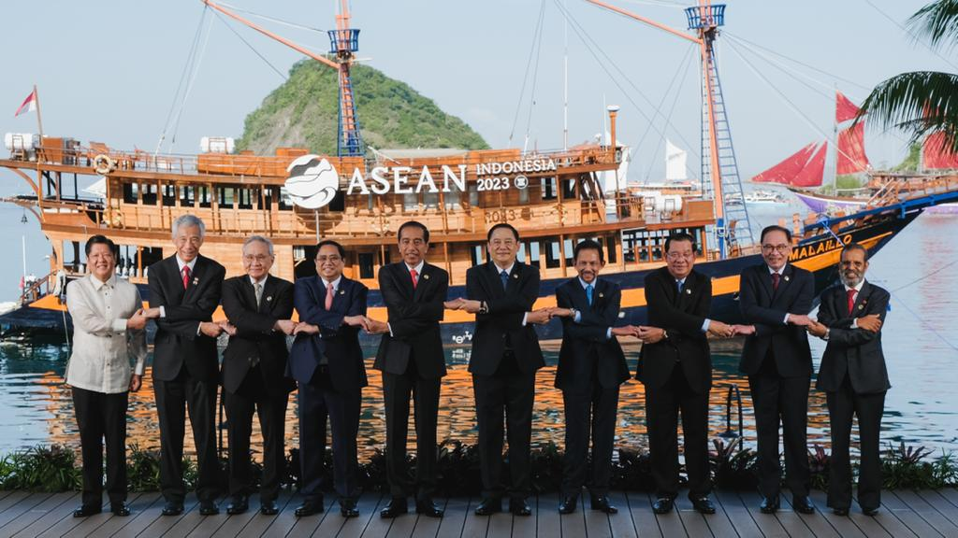

Indonesian President Joko Widodo chairs five meetings on the first day of the 42nd ASEAN Summit 2023, Wednesday (10/5/2023). (Photo: ASEAN2023 Host Photographer).

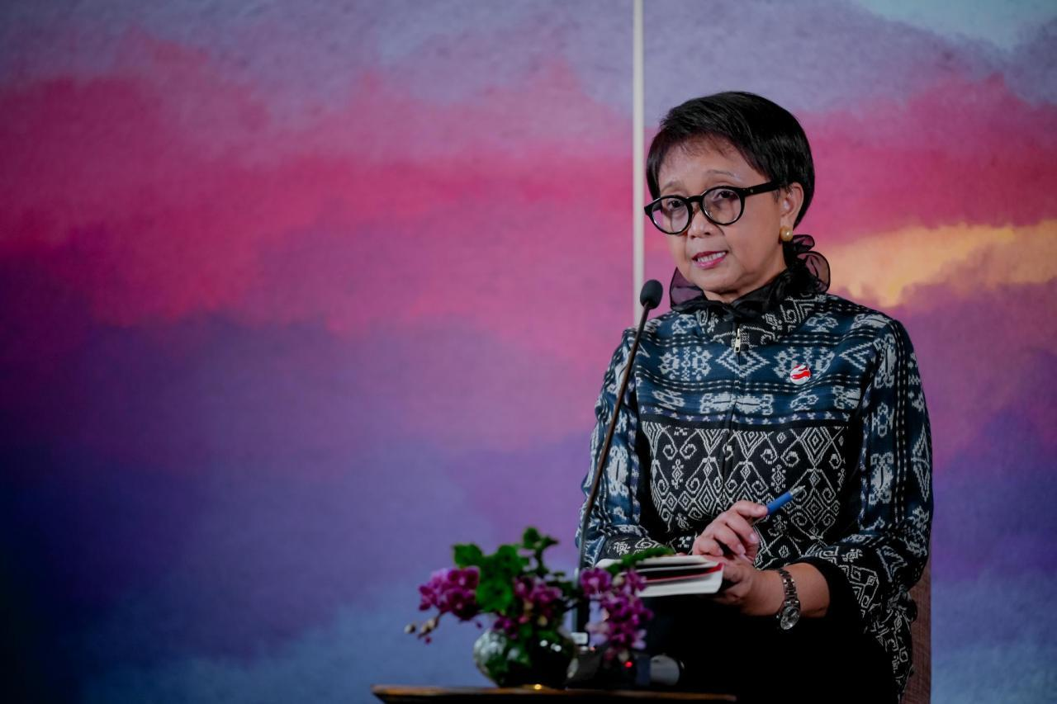

Minister for Foreign Affairs in her statement after accompanying the Indonesian President Joko Widodo in a number of bilateral meetings with ASEAN leaders in Hotel Meruorah, Labuan Bajo, West Manggarai Regency, East Nusa Tenggara (NTT) Province on Tuesday (9/5/2023) (Photo: BPMI-Ministry of Foreign Affairs).

